**Mobile Application Lab Programs**

1. **Creating “Hello world” Application**

**Steps to create:**

* Click **Start-** Android **Studio**, a **Welcome to Android Studio** dialog box will appear. Click **New Project**, the **New Project Dialog box** appears.
* Choose **Empty Views Activity** then click **Next**.
* Specify the **Name** of your project, Select the **Language** as **Java**, and Select the

**SDK as API 24(“Nougat”,Android 7.0).**Click **Finish** Button.

* Update the following code **in activity_main.xml and MainActivity.java**
* Click **Run app** or **shift+F10** to execute the application.

**activity_main.xml**

<?xml version="1.0" encoding="utf-8"?>  
<androidx.constraintlayout.widget.ConstraintLayout  
 xmlns:android="http://schemas.android.com/apk/res/android"  
 xmlns:app="http://schemas.android.com/apk/res-auto"  
 xmlns:tools="http://schemas.android.com/tools"  
 android:layout_width="match_parent"  
 android:layout_height="match_parent"  
 tools:context=".MainActivity">  
  
 <TextView  
 android:layout_width="wrap_content"  
 android:layout_height="wrap_content"  
 android:text="Hello World!"  
 app:layout_constraintBottom_toBottomOf="parent"  
 app:layout_constraintEnd_toEndOf="parent"  
 app:layout_constraintStart_toStartOf="parent"  
 app:layout_constraintTop_toTopOf="parent"  
 android:textSize="30sp"/>  
  
</androidx.constraintlayout.widget.ConstraintLayout>

**MainActivity.java**

package com.example.bca.lab1program;  
  
import androidx.appcompat.app.AppCompatActivity;  
import android.os.Bundle;  
public class MainActivity extends AppCompatActivity  
{  
 protected void onCreate(Bundle savedInstanceState)  
 {  
 super.onCreate(savedInstanceState);  
 setContentView(R.layout.*activity_main*);  
 }  
}

**Output**

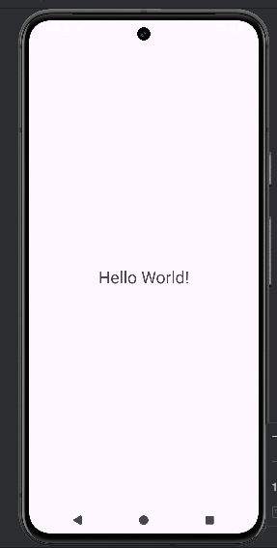

**2 Creating an application that displays message based on the screen orientation.**

**Steps:**

* Click **Start - Android Studio**, a **Welcome to Android Studio** dialog box will appear.
* Click **New Project**, the **New Project Dialog box** appears.
* Choose **Empty Views Activity** then click **Next**.
* Specify the **Name** of your project, Select the **Language** as **Java**, and Select the
* **SDK as API 24(“Nougat”,Android 7.0).**Click **Finish** Button.
* Update the following code **in activity_main.xml, activity_main2.xml, MainActivity.java and MainActivity2.java**
* Update the following code **in app manifests AndroidManifest.xml**
* To Create another activity **right click on app – new activity-Empty views Activity.**
* Update the following code **in activity_main2.xml and MainActivity2.java.**
* **Click Run App or Shift+F10** to execute the application.

**AndroidManifest.xml**

<?xml version="1.0" encoding="utf-8"?>  
<manifest xmlns:android="http://schemas.android.com/apk/res/android"  
 xmlns:tools="http://schemas.android.com/tools">  
 <application  
 android:allowBackup="true" android:dataExtractionRules="@xml/data_extraction_rules"  
 android:fullBackupContent="@xml/backup_rules"  
 android:icon="@mipmap/ic_launcher"  
 android:label="@string/app_name"  
 android:roundIcon="@mipmap/ic_launcher_round"  
 android:supportsRtl="true"  
 android:theme="@style/Theme.Program2"  
 tools:targetApi="31">  
 <activity  
 android:name=".MainActivity2"  
 android:exported="false"  
 android:screenOrientation="landscape" />  
 <activity  
 android:name=".MainActivity"  
 android:exported="true"  
 android:screenOrientation="portrait" >  
 <intent-filter>  
 <action android:name="android.intent.action.MAIN" />  
 <category android:name="android.intent.category.LAUNCHER"/>  
 </intent-filter>  
 </activity>  
 </application>  
</manifest>

**Activity_main.xml**

<?xml version="1.0" encoding="utf-8"?>  
<androidx.constraintlayout.widget.ConstraintLayout  
 xmlns:android="http://schemas.android.com/apk/res/android"  
 xmlns:app="http://schemas.android.com/apk/res-auto"  
 xmlns:tools="http://schemas.android.com/tools"  
 android:layout_width="match_parent"  
 android:layout_height="match_parent"  
 tools:context=".MainActivity">  
  
 <Button  
 android:id="@+id/button1"  
 android:layout_width="wrap_content"  
 android:layout_height="wrap_content"  
 android:layout_marginBottom="8dp"  
 android:layout_marginTop="112dp"  
 android:onClick="onClick"  
 android:text="Launch next activity"  
 app:layout_constraintBottom_toBottomOf="parent"  
 app:layout_constraintEnd_toEndOf="parent"  
 app:layout_constraintHorizontal_bias="0.612"  
 app:layout_constraintStart_toStartOf="parent"  
 app:layout_constraintTop_toBottomOf="@+id/editText1"  
 app:layout_constraintVertical_bias="0.613" />  
  
 <TextView  
 android:id="@+id/editText1"  
 android:layout_width="wrap_content"  
 android:layout_height="wrap_content"  
 android:layout_centerHorizontal="true"  
 android:layout_marginEnd="8dp"  
 android:layout_marginStart="8dp"  
 android:layout_marginTop="124dp"  
 android:ems="10"  
 android:textSize="22dp"  
 android:text="This activity is portrait orientation"  
 app:layout_constraintEnd_toEndOf="parent"  
 app:layout_constraintHorizontal_bias="0.502"  
 app:layout_constraintStart_toStartOf="parent"  
 app:layout_constraintTop_toTopOf="parent" />  
  
</androidx.constraintlayout.widget.ConstraintLayout>

**MainActivity.java**

package com.example.bca.program2;  
  
import androidx.appcompat.app.AppCompatActivity;  
import android.content.Intent;  
import android.os.Bundle;  
import android.view.View;  
  
public class MainActivity extends AppCompatActivity {  
  
 @Override  
 protected void onCreate(Bundle savedInstanceState) {  
 super.onCreate(savedInstanceState);  
 setContentView(R.layout.*activity_main*);  
 }  
  
 public void onClick(View v)  
 {  
 Intent intent = new Intent(MainActivity.this,MainActivity2.class);  
 startActivity(intent);  
 }  
}

**activity_main2.xml**

<?xml version="1.0" encoding="utf-8"?>  
<androidx.constraintlayout.widget.ConstraintLayout  
 xmlns:android="http://schemas.android.com/apk/res/android"  
 xmlns:app="http://schemas.android.com/apk/res-auto"  
 xmlns:tools="http://schemas.android.com/tools"  
 android:layout_width="match_parent"  
 android:layout_height="match_parent"  
 tools:context=".MainActivity2">  
  
 <TextView  
 android:id="@+id/textView"  
 android:layout_width="wrap_content"  
 android:layout_height="wrap_content"  
 android:layout_marginEnd="8dp"  
 android:layout_marginStart="8dp"  
 android:layout_marginTop="180dp"  
 android:text="this is landscape orientation"  
 android:textSize="22dp"  
 app:layout_constraintEnd_toEndOf="parent"  
 app:layout_constraintHorizontal_bias="0.502"  
 app:layout_constraintStart_toStartOf="parent"  
 app:layout_constraintTop_toTopOf="parent" />  
  
</androidx.constraintlayout.widget.ConstraintLayout>

**MainActivity2.java**

package com.example.bca.program2;  
  
import androidx.appcompat.app.AppCompatActivity;  
import android.os.Bundle;  
  
public class MainActivity2 extends AppCompatActivity {  
  
 @Override  
 protected void onCreate(Bundle savedInstanceState) {  
 super.onCreate(savedInstanceState);  
 setContentView(R.layout.*activity_main2*);  
 }  
}

**Output**

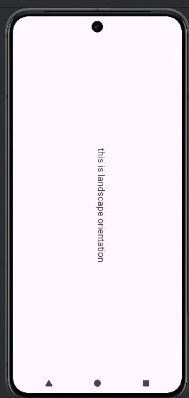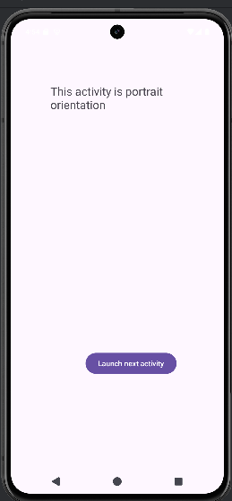

3 Create an application to develop Login window using UI controls.

Steps:

* Click **New Project**, the **New Project Dialog box** appears
* Choose **Empty Views Activity** then click **Next**.
* Specify the **Name** of your project, Select the **Language** as **Java**, and Select the **SDK as API 24(“Nougat”,Android 7.0).**Click **Finish** Button.
* Create **background** resources (**bg_outer.xml**)
  + To create resource file, click **appresdrawable.** Right click **drawableNew Drawable Resource File.** The **New Resource File** dialog box appears.
  + Set **filename** as **bg_outer.xml**, **root element** as **shape** and then click **ok.**
* Modify the **bg_outer.xml** file
* Create **background** resources (**bg_inner.xml**)
  + To create resource file, click **appresdrawable.** Right click **drawableNew Drawable Resource File.** The **New Resource File** dialog box appears.
  + Set **filename** as **bg_inner.xml**, **root element** as **shape** and then click **ok.**
* Modify the **bg_inner.xml** file
* Click **Run App or Shift+F10** to execute the application.

**activity_main.xml**

<?xml version="1.0" encoding="utf-8"?>  
<RelativeLayout xmlns:android="http://schemas.android.com/apk/res/android"  
 xmlns:app="http://schemas.android.com/apk/res-auto"  
 xmlns:tools="http://schemas.android.com/tools"  
 android:id="@+id/main"  
 android:layout_width="match_parent"  
 android:layout_height="match_parent"  
 tools:context=".MainActivity"  
 android:background="@drawable/bg_outer">  
  
 <LinearLayout  
 android:layout_width="match_parent"  
 android:layout_height="wrap_content"  
 android:gravity="center"  
 android:layout_centerInParent="true"  
 android:orientation="vertical"  
 android:background="@drawable/bg_inner"  
 android:padding="30dp">  
 <TextView  
 android:layout_width="wrap_content"  
 android:layout_height="wrap_content"  
 android:text="Login Page"  
 android:textSize="32sp"  
 android:textStyle="bold"  
 android:fontFamily="sansserifcondensedmedium"  
 android:textColor="@color/black"  
 android:paddingBottom="20dp"/>  
  
 <EditText  
 android:id="@+id/editTextUsername"  
 android:layout_width="match_parent"  
 android:layout_height="wrap_content"  
 android:hint="Username"  
 android:layout_marginBottom="16dp"/>  
  
 <EditText  
 android:id="@+id/editTextPassword"  
 android:layout_width="match_parent"  
 android:layout_height="wrap_content"  
 android:hint="Password"  
 android:layout_below="@id/editTextUsername"  
 android:layout_marginBottom="16dp"  
 android:inputType="textPassword"/>  
  
 <Button  
 android:id="@+id/buttonLogin"  
 android:layout_width="wrap_content"  
 android:layout_height="wrap_content"  
 android:text="Login"  
 android:layout_below="@id/editTextPassword"/>  
  
 </LinearLayout>  
</RelativeLayout>

**bg_inner.xml**

<?xml version="1.0" encoding="utf-8"?>  
<shape xmlns:android="http://schemas.android.com/apk/res/android">  
 <gradient  
 android:startColor="#84FFFF"  
 android:endColor="#f08"  
 android:angle="100"/>  
 <corners android:radius="20dp"/>  
</shape>

**bg_outer.xml**

<?xml version="1.0" encoding="utf-8"?>  
<shape xmlns:android="http://schemas.android.com/apk/res/android">  
 <corners  
 android:radius="12dp" />  
 <gradient  
 android:startColor="#B388FF"  
 android:endColor="#397C9A"  
 android:angle="100"/>  
</shape>

**MainActivity.java**

package com.example.bca.loginpgm;  
import android.os.Bundle;  
import android.view.View;  
import android.widget.Button;  
import android.widget.EditText;  
import android.widget.Toast;  
import androidx.activity.EdgeToEdge;  
import androidx.appcompat.app.AppCompatActivity;  
  
public class MainActivity extends AppCompatActivity  
{  
 private EditText editTextUsername,editTextPassword;  
 private Button buttonLogin;  
 @Override protected void onCreate(Bundle savedInstanceState)  
 {  
 super.onCreate(savedInstanceState);  
 setContentView(R.layout.*activity_main*);  
 editTextUsername = findViewById(R.id.*editTextUsername*);  
 editTextPassword = findViewById(R.id.*editTextPassword*);  
 buttonLogin = findViewById(R.id.*buttonLogin*);  
 buttonLogin.setOnClickListener(new View.OnClickListener()  
 {  
 @Override  
 public void onClick(View v)  
 {  
 String username = editTextUsername.getText().toString().trim();  
 String password = editTextPassword.getText().toString().trim();  
 if(username.equals("admin") && password.equals("pass"))  
 {  
 Toast.*makeText*(MainActivity.this, "Login successful",Toast.*LENGTH_SHORT*).show();  
 } else  
 {  
 Toast.*makeText*(MainActivity.this, "Invalid username or password", Toast.*LENGTH_SHORT*).show();  
 }  
 }  
 });  
 }  
}

**OUTPUT**

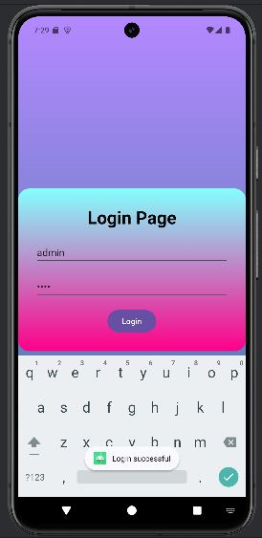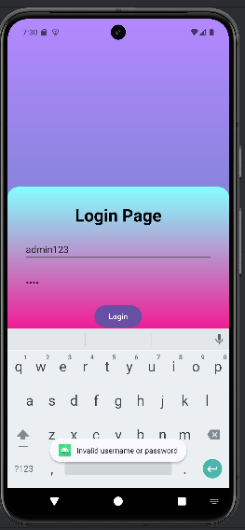

4 **Create an application to implement new activity using explicit intent, implicit intent and content provider.**

**Steps: Follow Program 2**

**activity_new.xml**

<?xml version="1.0" encoding="utf-8"?>  
<androidx.constraintlayout.widget.ConstraintLayout  
 xmlns:android="http://schemas.android.com/apk/res/android"  
 xmlns:app="http://schemas.android.com/apk/res-auto"  
 xmlns:tools="http://schemas.android.com/tools"  
 android:id="@+id/main"  
 android:layout_width="match_parent"  
 android:layout_height="match_parent"  
 tools:context=".NewActivity">  
  
 <TextView android:id="@+id/textView"  
 android:layout_width="wrap_content"  
 android:layout_height="wrap_content"  
 android:text="Welcome to Explicit Intent"  
 android:textSize="28sp"  
 app:layout_constraintBottom_toBottomOf="parent"  
 app:layout_constraintEnd_toEndOf="parent"  
 app:layout_constraintStart_toStartOf="parent"  
 app:layout_constraintTop_toTopOf="parent" />  
  
</androidx.constraintlayout.widget.ConstraintLayout>

**MainActivity.java**

package com.example.bca.intents;  
  
import android.content.Intent;  
import android.net.Uri;  
import android.os.Bundle;  
import android.view.View;  
import androidx.activity.EdgeToEdge;  
import androidx.appcompat.app.AppCompatActivity;  
import androidx.core.graphics.Insets;  
import androidx.core.view.ViewCompat;  
import androidx.core.view.WindowInsetsCompat;  
  
public class MainActivity extends AppCompatActivity  
{  
 @Override  
 protected void onCreate(Bundle savedInstanceState)  
 {  
 super.onCreate(savedInstanceState);  
 EdgeToEdge.*enable*(this);  
 setContentView(R.layout.*activity_main*);  
 }  
 public void onImplicitButtonClicked(View view)  
 {  
 Uri url=Uri.*parse*("https://www.google.com");  
 Intent i=new Intent(Intent.*ACTION_VIEW*, url);  
 startActivity(i);  
 }  
 public void onExplicitButtonClicked(View view )  
 {  
 Intent i=new Intent(MainActivity.this, Activity_new.class);  
 startActivity(i);  
 }  
}

**activity_main.xml**

<?xml version="1.0" encoding="utf-8"?>  
<LinearLayout xmlns:android="http://schemas.android.com/apk/res/android"  
 xmlns:app="http://schemas.android.com/apk/res-auto"  
 xmlns:tools="http://schemas.android.com/tools"  
 android:id="@+id/main"  
 android:layout_width="match_parent"  
 android:layout_height="match_parent"  
 android:gravity="center" tools:context=".MainActivity">  
  
 <Button  
 android:layout_width="wrap_content"  
 android:layout_height="wrap_content"  
 android:text="Implicit Intent"  
 android:onClick="onImplicitButtonClicked" />  
  
 <Button  
 android:layout_width="wrap_content"  
 android:layout_height="wrap_content"  
 android:text="Explicit Intent"  
 android:onClick="onExplicitButtonClicked"/>  
  
</LinearLayout>

**Activity_new.java**

package com.example.bca.intents;  
  
import android.os.Bundle;  
import androidx.appcompat.app.AppCompatActivity;  
  
public class Activity_new extends AppCompatActivity {  
  
 @Override  
 protected void onCreate(Bundle savedInstanceState) {  
 super.onCreate(savedInstanceState);  
 setContentView(R.layout.*activity_new*);  
 }  
}

**Output**

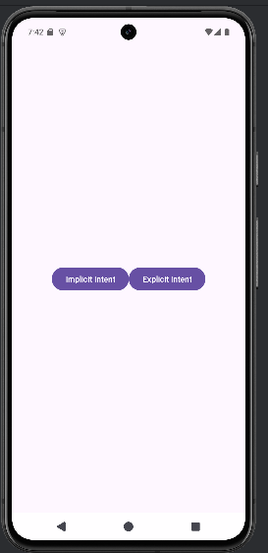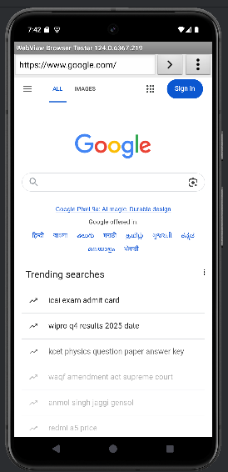 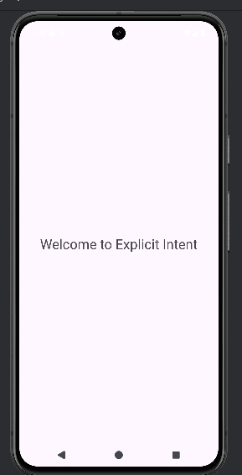

**5. Create an application that displays custom designed Opening Screen.**

**Steps:**

**1. Click New Project, the New Project Dialog box appears.**

**2. Choose Empty Views Activity then click Next.**

**3. Specify the Name of your project, Select the Language as Java, and Select the SDK as API 24(“Nougat”,Android 7.0).Click Finish Button.**

**4. To create another activity for Home Page, Right Click App NewActivity Empty Views Activity. A New Android Activity dialog box appears, Specify the Name of the activity as mainScreen then click Finish.**

**5. Create one TextView resource in activity_mainScreen.xml and update the following code**

**Activity_main.xml**

<?xml version="1.0" encoding="utf-8"?>  
<RelativeLayout  
 xmlns:android="http://schemas.android.com/apk/res/android"  
 xmlns:app="http://schemas.android.com/apk/res-auto"  
 xmlns:tools="http://schemas.android.com/tools"  
 android:id="@+id/main"  
 android:layout_width="match_parent"  
 android:layout_height="match_parent"  
 tools:context=".MainActivity"  
 android:gravity="center">  
  
 <ImageView  
 android:layout_width="183dp"  
 android:layout_height="364dp"  
 android:src="@drawable/welcome" />  
  
</RelativeLayout>

**Activity_mainscreen.xml**

<?xml version="1.0" encoding="utf-8"?>  
<RelativeLayout xmlns:android="http://schemas.android.com/apk/res/android"  
 xmlns:app="http://schemas.android.com/apk/res-auto"  
 xmlns:tools="http://schemas.android.com/tools"  
 android:id="@+id/main"  
 android:layout_width="match_parent"  
 android:layout_height="match_parent"  
 tools:context=".mainScreen"  
 android:gravity="center"  
 android:background="#7E6C29">  
  
 <TextView  
 android:layout_width="wrap_content"  
 android:layout_height="wrap_content"  
 android:text="Welcome to home Page"  
 android:textStyle="bold"  
 android:textSize="32sp"  
 android:textColor="@color/black"/>  
  
</RelativeLayout>

**Mainactivity.java**

import android.content.Intent;  
import android.os.Bundle;  
import android.os.Handler;  
import android.view.WindowManager;  
import androidx.activity.EdgeToEdge;  
import androidx.appcompat.app.AppCompatActivity;  
import androidx.core.graphics.Insets;  
import androidx.core.view.ViewCompat;  
import androidx.core.view.WindowInsetsCompat;  
  
public class MainActivity extends AppCompatActivity {  
  
 private static final int *SPLASH_SCREEN_TIME_OUT* = 10000;

@Override  
 protected void onCreate(Bundle savedInstanceState)  
 {  
 super.onCreate(savedInstanceState);  
 EdgeToEdge.*enable*(this);  
 setContentView(R.layout.*activity_main*);  
 getWindow().setFlags(WindowManager.LayoutParams.*FLAG_FULLSCREEN*,  
 WindowManager.LayoutParams.*FLAG_FULLSCREEN*);  
 new Handler().postDelayed(new Runnable()  
 {  
 @Override  
 public void run()  
 {  
 Intent i = new Intent(MainActivity.this, mainScreen.class);  
 startActivity(i);  
 finish();  
 }  
 }, *SPLASH_SCREEN_TIME_OUT*);  
 }  
}

**Mainscreen.java**

import android.os.Bundle;  
import androidx.activity.EdgeToEdge;  
import androidx.appcompat.app.AppCompatActivity;  
import androidx.core.graphics.Insets;  
import androidx.core.view.ViewCompat;  
import androidx.core.view.WindowInsetsCompat;  
  
public class mainScreen extends AppCompatActivity {  
  
 @Override  
 protected void onCreate(Bundle savedInstanceState) {  
 super.onCreate(savedInstanceState);  
 EdgeToEdge.*enable*(this);  
 setContentView(R.layout.*activity_main_screen*);  
 ViewCompat.*setOnApplyWindowInsetsListener*(findViewById(R.id.*main*), (v, insets) -> {  
 Insets systemBars = insets.getInsets(WindowInsetsCompat.Type.*systemBars*());  
 v.setPadding(systemBars.left, systemBars.top, systemBars.right, systemBars.bottom);  
 return insets;  
 });  
 }  
}

**Output**

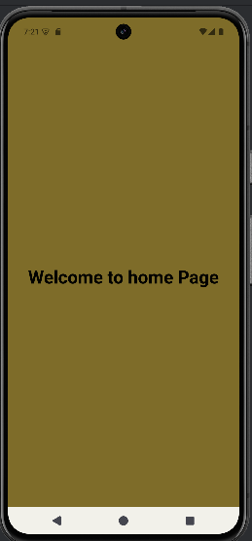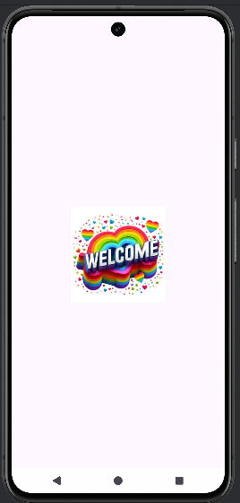

**6. Create an UI with all views.**

**Steps:**

**1. Click New Project, the New Project Dialog box appears.**

**2. Choose Empty Views Activity then click Next.**

**3. Specify the Name of your project, Select the Language as Java, and Select the SDK as API 24(“Nougat”,Android 7.0).Click Finish Button.**

**4. Create background resources(bg_outer.xml, bg_inner.xml, bg.xml)**

**a. To create resource file click appresdrawable. Right click drawableNew Drawable Resource File. The New Resource File dialog box appears.**

**b. Set filename as bg_outer.xml, root element as shape and then click ok. Modify the bg_outer.xml file**

<?xml version="1.0" encoding="utf-8"?>  
<shape xmlns:android="http://schemas.android.com/apk/res/android">  
 <gradient  
 android:startColor="#64EFAE"  
 android:endColor="#84FFFF"  
 android:angle="120"  
 android:gradientRadius="5dp"/>  
 <corners  
 android:radius="20dp"/>  
</shape>

**C. Create another background resource for inner layout. Set filename as bg_inner.xml, root element as shape and then click ok. Modify the bg_inner.xml file**

<?xml version="1.0" encoding="utf-8"?>  
<shape xmlns:android="http://schemas.android.com/apk/res/android">  
 <gradient  
 android:startColor="#64F194"  
 android:endColor="#B242C5"  
 android:angle="120"  
 android:gradientRadius="5dp"/>  
 <corners  
 android:radius="20dp"  
 android:topLeftRadius="70dp"  
 android:bottomRightRadius="70dp"/>  
</shape>

**D. create another background resource for view. Set filename as bg.xml, root element as shape and then click ok. Modify the bg..xml file**

<?xml version="1.0" encoding="utf-8"?>  
<shape xmlns:android="http://schemas.android.com/apk/res/android">  
 <solid  
 android:color="#2860F367"/>  
 <corners  
 android:radius="30dp" />  
 <stroke  
 android:color="#00BFA5"  
 android:width="2dp"/>  
</shape>

**activity_main.xml**

<?xml version="1.0" encoding="utf-8"?>  
<LinearLayout  
 xmlns:android="http://schemas.android.com/apk/res/android"  
 xmlns:app="http://schemas.android.com/apk/res-auto"  
 xmlns:tools="http://schemas.android.com/tools"  
 android:id="@+id/main"  
 android:layout_width="match_parent"  
 android:layout_height="match_parent"  
 tools:context=".MainActivity"  
 android:gravity="center"  
 android:orientation="vertical"  
 android:padding="30dp"  
 android:background="@drawable/bg_outer">  
  
 <TextView  
 android:layout_width="wrap_content"  
 android:layout_height="wrap_content"  
 android:text="User Information"  
 android:textSize="30sp"  
 android:textStyle="bold"  
 android:textColor="#26389C" />  
  
 <ImageView  
 android:layout_width="wrap_content"  
 android:layout_height="wrap_content"  
 android:src="@drawable/img"/>  
  
 <ToggleButton  
 android:layout_width="wrap_content"  
 android:layout_height="wrap_content"  
 android:textOn="Active"  
 android:textOff="Inactive"/>  
  
 <View  
 android:layout_width="match_parent"  
 android:layout_height="40dp"/>  
  
 <LinearLayout  
 android:layout_width="match_parent"  
 android:layout_height="wrap_content"  
 android:paddingTop="30dp"  
 android:paddingBottom="30dp"  
 android:paddingLeft="5dp"  
 android:paddingRight="5dp"  
 android:orientation="vertical"  
 android:background="@drawable/bg_inner">  
 <LinearLayout  
 android:layout_width="match_parent"  
 android:layout_height="wrap_content"  
 android:orientation="horizontal"  
 android:padding="5dp">  
 <TextView  
 android:layout_width="wrap_content"  
 android:layout_height="wrap_content"  
 android:text="Name"  
 android:textSize="20sp"  
 android:textStyle="bold"  
 android:textColor="#26389C"  
 android:padding="15dp"/>  
  
 <EditText  
 android:layout_width="match_parent"  
 android:layout_height="60dp"  
 android:id="@+id/name"  
 android:background="@drawable/bg"  
 android:padding="15dp"/>  
 </LinearLayout>  
  
 <LinearLayout  
 android:layout_width="match_parent"  
 android:layout_height="wrap_content"  
 android:orientation="horizontal"  
 android:padding="5dp">  
 <TextView  
 android:layout_width="wrap_content"  
 android:layout_height="wrap_content"  
 android:text="Email"  
 android:textSize="20sp"  
 android:textStyle="bold"  
 android:textColor="#26389C"  
 android:padding="15dp"/>  
 <EditText  
 android:id="@+id/email"  
 android:layout_width="match_parent"  
 android:layout_height="60dp"  
 android:ems="10"  
 android:inputType="textEmailAddress"  
 android:background="@drawable/bg"  
 android:padding="15dp"/>  
 </LinearLayout>  
 <LinearLayout  
 android:layout_width="match_parent"  
 android:layout_height="wrap_content"  
 android:orientation="horizontal"  
 android:padding="5dp">  
 <TextView  
 android:layout_width="wrap_content"  
 android:layout_height="wrap_content"  
 android:text="Sex"  
 android:textSize="20sp"  
 android:textStyle="bold"  
 android:textColor="#26389C"  
 android:padding="15dp"  
 android:paddingEnd="40dp"/>  
 <RadioGroup  
 android:layout_width="wrap_content"  
 android:layout_height="wrap_content"  
 android:background="@drawable/bg"  
 android:orientation="horizontal"  
 android:id="@+id/sex">  
  
 <RadioButton  
 android:layout_width="wrap_content"  
 android:layout_height="wrap_content"  
 android:id="@+id/male"  
 android:padding="15dp"  
 android:text="Male"  
 android:textColor="#26389C"  
 android:textSize="20sp"  
 android:textStyle="bold" />  
 <RadioButton  
 android:layout_width="wrap_content"  
 android:layout_height="wrap_content"  
 android:id="@+id/female"  
 android:padding="15dp"  
 android:text="Female"  
 android:textColor="#26389C"  
 android:textSize="20sp"  
 android:textStyle="bold" />  
 </RadioGroup>  
 </LinearLayout>  
 <LinearLayout  
 android:layout_width="match_parent"  
 android:layout_height="wrap_content"  
 android:orientation="horizontal"  
 android:padding="5dp">  
 <TextView  
 android:layout_width="wrap_content"  
 android:layout_height="wrap_content"  
 android:text="Country"  
 android:textSize="20sp"  
 android:textStyle="bold"  
 android:textColor="#26389C"  
 android:padding="15dp"  
 android:paddingEnd="5dp" />  
 <Spinner  
 android:layout_width="match_parent"  
 android:layout_height="60dp"  
 android:id="@+id/country"  
 android:padding="15dp"  
 android:background="@drawable/bg"/>  
 </LinearLayout>  
 </LinearLayout>  
 <View  
 android:layout_width="match_parent"  
 android:layout_height="40dp"/>  
 <Button  
 android:layout_width="210dp"  
 android:layout_height="wrap_content"  
 android:id="@+id/submit"  
 android:background="@drawable/bg"  
 android:padding="15dp"  
 android:text="Submit"  
 android:textColor="#26389C"  
 android:textSize="20sp"  
 android:textStyle="bold" />  
</LinearLayout>

**MainActivity.java**

import android.app.Dialog;  
import android.content.Context;  
import android.content.DialogInterface;  
import android.os.Bundle;  
import android.view.View;  
import android.view.ViewGroup;  
import android.widget.ArrayAdapter;  
import android.widget.Button;  
import android.widget.EditText;  
import android.widget.RadioButton;  
import android.widget.RadioGroup;  
import android.widget.Spinner;  
import android.widget.Toast;  
import androidx.activity.EdgeToEdge;  
import androidx.appcompat.app.AlertDialog;  
import androidx.appcompat.app.AppCompatActivity;  
import androidx.core.graphics.Insets;  
import androidx.core.view.ViewCompat;  
import androidx.core.view.WindowInsetsCompat;  
  
public class MainActivity extends AppCompatActivity  
{  
 Button sub;  
 @Override  
 protected void onCreate(Bundle savedInstanceState)  
 {  
 super.onCreate(savedInstanceState);  
 EdgeToEdge.*enable*(this);  
 setContentView(R.layout.*activity_main*);  
 Button sub=findViewById(R.id.*submit*);  
  
 sub.setOnClickListener(new View.OnClickListener()  
 {  
 @Override  
 public void onClick(View v)  
 {  
 showMessage(MainActivity.this,"User Information","Successfully completed");  
 }  
 });  
 String[] item=new String[]{"India", "Pakistan", "China", "America", "England"};  
 ArrayAdapter adapter = new ArrayAdapter<>(this,  
 android.R.layout.*simple_spinner_item*, item);  
 adapter.setDropDownViewResource(android.R.layout.*simple_spinner_dropdown_item*);  
 Spinner spinner = findViewById(R.id.*country*);  
 spinner.setAdapter(adapter);  
 }  
 public void showMessage(Context con,String t, String msg)  
 {  
 AlertDialog.Builder builder = new AlertDialog.Builder(con);  
 builder.setTitle(t);  
 builder.setMessage(msg);  
 builder.setPositiveButton("OK", new DialogInterface.OnClickListener()  
 {  
 @Override  
 public void onClick(DialogInterface dialog, int which)  
 {  
 dialog.dismiss();  
 }  
 });  
 builder.show();  
 }  
}

**Output**

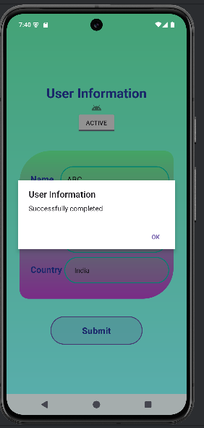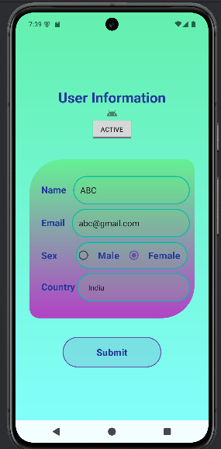

**7 Create menu in Application**

**1. Click New Project, the New Project Dialog box appears.**

**2. Choose Empty Views Activity then click Next.**

**3. Specify the Name of your project, Select the Language as Java, and Select the SDK as API 24(“Nougat”,Android 7.0).Click Finish Button.**

**4. To create another activity for Home Page, Right Click AppNewActivity Empty Views Activity. A New Android Activity dialog box appears, Specify the Name of the activity as HomeScreen then click Finish.**

**5. To create a Menu Resource File: Rightclick on the res directory in your Android project, navigate to New Android Resource File, and name the file menus.xml, Root element as Menu and update the following content.**

<?xml version="1.0" encoding="utf-8"?>  
<menu xmlns:android="http://schemas.android.com/apk/res/android">  
 <item  
 android:id="@+id/php"  
 android:title="PHP"/>  
 <item  
 android:id="@+id/java"  
 android:title="JAVA"/>  
 <item android:id="@+id/csharp"  
 android:title="C#"/>  
</menu>

**MainActivity.java**

import android.content.Intent;  
import android.os.Bundle;  
import android.view.Menu;  
import android.view.MenuInflater;  
import android.view.MenuItem;  
import android.widget.Toast;  
import androidx.activity.EdgeToEdge;  
import androidx.annotation.NonNull;  
import androidx.appcompat.app.AppCompatActivity;  
import androidx.core.graphics.Insets;  
import androidx.core.view.ViewCompat;  
import androidx.core.view.WindowInsetsCompat;  
  
public class MainActivity extends AppCompatActivity {  
  
 @Override protected void onCreate(Bundle savedInstanceState)  
 {  
 super.onCreate(savedInstanceState);  
 EdgeToEdge.*enable*(this);  
 setContentView(R.layout.*activity_main*);  
 }  
 @Override  
 public boolean onCreatePanelMenu(int featureId, @NonNull Menu menu)  
 {  
 MenuInflater inflater=getMenuInflater();  
 inflater.inflate(R.menu.*menus*,menu);  
 return true;  
 }  
 @Override  
 public boolean onOptionsItemSelected(@NonNull MenuItem item)  
 {  
 if(item.getItemId()==R.id.*php*)  
 {  
 Toast.*makeText*(this, "Php Page", Toast.*LENGTH_SHORT*).show();  
 }  
 if(item.getItemId()==R.id.*java*)  
 {  
 Toast.*makeText*(this, "Java Page", Toast.*LENGTH_SHORT*).show();  
 }  
 if(item.getItemId()==R.id.*csharp*)  
 {  
 Toast.*makeText*(this, "C# Page", Toast.*LENGTH_SHORT*).show();  
 }  
 return super.onOptionsItemSelected(item);  
 }  
}

**Set the UsesPermission in AndroidManifest.xml**

<?xml version="1.0" encoding="utf-8"?>  
<manifest xmlns:android="http://schemas.android.com/apk/res/android"  
 xmlns:tools="http://schemas.android.com/tools">  
 <uses-permission  
 android:name="android.permission.INTERNET" />  
 <application  
 android:allowBackup="true"  
 android:dataExtractionRules="@xml/data_extraction_rules"  
 android:fullBackupContent="@xml/backup_rules"  
 android:icon="@mipmap/ic_launcher"  
 android:label="@string/app_name"  
 android:roundIcon="@mipmap/ic_launcher_round"  
 android:supportsRtl="true"  
 android:theme="@style/Theme.AppCompat.Light"  
 tools:targetApi="31">  
 <activity  
 android:name=".MainActivity"  
 android:exported="true">  
 <intent-filter>  
 <action android:name="android.intent.action.MAIN" />  
 <category android:name="android.intent.category.LAUNCHER" />  
 </intent-filter>  
 </activity>  
 </application>  
</manifest>

**Activity_main.xml**

<?xml version="1.0" encoding="utf-8"?>  
<androidx.constraintlayout.widget.ConstraintLayout  
 xmlns:android="http://schemas.android.com/apk/res/android"  
 xmlns:app="http://schemas.android.com/apk/res-auto"  
 xmlns:tools="http://schemas.android.com/tools"  
 android:id="@+id/main"  
 android:layout_width="match_parent"  
 android:layout_height="match_parent"  
 tools:context=".MainActivity">  
  
</androidx.constraintlayout.widget.ConstraintLayout>

**Output**

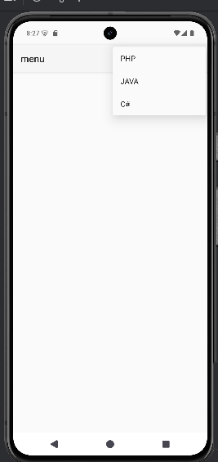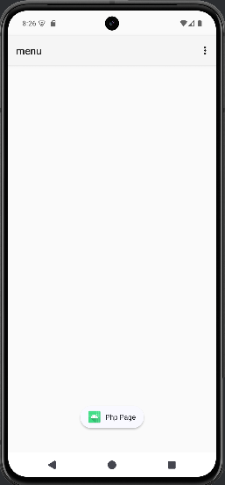

**8 Read/ write the Local data**

**activity_main.xml**

<?xml version="1.0" encoding="utf-8"?>  
<LinearLayout  
 xmlns:android="http://schemas.android.com/apk/res/android"  
 xmlns:app="http://schemas.android.com/apk/res-auto"  
 xmlns:tools="http://schemas.android.com/tools"  
 android:id="@+id/main"  
 android:layout_width="match_parent"  
 android:layout_height="match_parent"  
 tools:context=".MainActivity"  
 android:orientation="vertical">  
  
 <TextView  
 android:layout_width="match_parent"  
 android:layout_height="wrap_content"  
 android:text="User Name">  
 </TextView>  
  
 <EditText  
 android:id="@+id/etUserName"  
 android:layout_width="match_parent"  
 android:layout_height="wrap_content" >  
 </EditText>  
  
 <TextView  
 android:layout_width="match_parent"  
 android:layout_height="wrap_content"  
 android:text="Password">  
 </TextView>  
  
 <EditText  
 android:id="@+id/etPassword"  
 android:layout_width="match_parent"  
 android:layout_height="wrap_content">  
 </EditText>  
  
 <Button  
 android:id="@+id/btnsave"  
 android:layout_width="wrap_content"  
 android:layout_height="wrap_content"  
 android:text="Save" />  
 <Button  
 android:id="@+id/btnnext"  
 android:layout_width="wrap_content"  
 android:layout_height="wrap_content"  
 android:text="Next" />  
  
</LinearLayout>

**MainActivity.java**

import androidx.appcompat.app.AppCompatActivity;  
import android.content.Context;  
import android.content.Intent;  
import android.content.SharedPreferences;  
import android.os.Bundle;  
import android.view.View;  
import android.widget.Button;  
import android.widget.EditText;  
import android.widget.Toast;  
  
public class MainActivity extends AppCompatActivity {  
  
 Button btnsave,btnnext;  
 EditText etUserName,etPassword;  
 @Override  
 protected void onCreate(Bundle savedInstanceState)  
 {  
 super.onCreate(savedInstanceState);  
 setContentView(R.layout.*activity_main*);  
 btnsave=(Button) findViewById(R.id.*btnsave*);  
 btnnext = (Button) findViewById(R.id.*btnnext*);  
 etUserName = (EditText)findViewById(R.id.*etUserName*);  
 etPassword = (EditText)findViewById(R.id.*etPassword*);  
 btnsave.setOnClickListener(new View.OnClickListener()  
 {  
 @Override  
 public void onClick(View view)  
 {  
 //Writing data to SharedPreferences  
 SharedPreferences sharedPreferences = getSharedPreferences  
 ("MyPrefs", Context.*MODE_PRIVATE*);  
 SharedPreferences.Editor editor = sharedPreferences.edit();  
 editor.putString("username", etUserName.getText().toString());  
 editor.putString("password",etPassword.getText().toString());  
 editor.apply();  
 Toast.*makeText*(getApplicationContext(),  
 "Saved successfully",Toast.*LENGTH_LONG*).show();  
 }  
 });  
 btnnext.setOnClickListener(new View.OnClickListener()  
 {  
 @Override  
 public void onClick(View view)  
 {  
 Intent intent = new Intent(getApplicationContext(),MainActivity2.class);  
 startActivity(intent);  
 }  
 });  
 }  
}

**activity_main2.xml**

<?xml version="1.0" encoding="utf-8"?>  
<LinearLayout  
 xmlns:android="http://schemas.android.com/apk/res/android"  
 xmlns:app="http://schemas.android.com/apk/res-auto"  
 xmlns:tools="http://schemas.android.com/tools"  
 android:id="@+id/main"  
 android:layout_width="match_parent"  
 android:layout_height="match_parent"  
 tools:context=".MainActivity2"  
 android:orientation="vertical">  
  
 <Button  
 android:id="@+id/btnFetch"  
 android:layout_width="wrap_content"  
 android:layout_height="93dp"  
 android:text="Fetch" />  
  
 <TextView  
 android:layout_width="match_parent"  
 android:layout_height="wrap_content"  
 android:text="User Name"></TextView>  
  
 <EditText  
 android:id="@+id/etUserName"  
 android:layout_width="match_parent"  
 android:layout_height="wrap_content" >  
 </EditText>  
  
 <TextView  
 android:layout_width="match_parent"  
 android:layout_height="wrap_content"  
 android:text="Password"></TextView>  
  
 <EditText  
 android:id="@+id/etPassword"  
 android:layout_width="match_parent"  
 android:layout_height="wrap_content" >  
 </EditText>  
  
</LinearLayout>

**MainActivity2.java**

import androidx.appcompat.app.AppCompatActivity;  
import android.content.Context;  
import android.content.SharedPreferences;  
import android.os.Bundle;  
import android.view.View;  
import android.widget.Button;  
import android.widget.EditText;  
  
public class MainActivity2 extends AppCompatActivity  
{  
 Button btnFetch;  
 EditText etUserName,etPassword;  
 @Override  
 protected void onCreate(Bundle savedInstanceState)  
 {  
 super.onCreate(savedInstanceState);  
 setContentView(R.layout.*activity_main2*);  
 btnFetch = (Button) findViewById(R.id.*btnFetch*);  
 etUserName = (EditText)findViewById(R.id.*etUserName*);  
 etPassword = (EditText)findViewById(R.id.*etPassword*);  
 btnFetch.setOnClickListener(new View.OnClickListener()  
 {  
 @Override  
 public void onClick(View view)  
 { // Reading data from SharedPreferences  
 SharedPreferences sharedPreferences = getSharedPreferences("MyPrefs",  
 Context.*MODE_PRIVATE*);  
 String username = sharedPreferences.getString("username",  
 "");  
 String password = sharedPreferences.getString("password",  
 ""); etUserName.setText(username);  
 etPassword.setText(password);  
 }  
 });  
 }  
}

**Output**

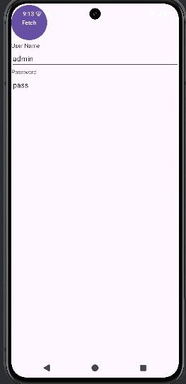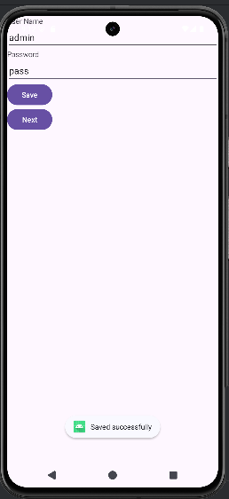

**9.Create / Read / Write data with database (SQL Lite)**

***HOW TO CREATE AN SQLITE DATABASE:***

In the AndroidManifest.xml file you add permission to access the storage.(Add before Application tag)

<uses-permission  
 android:name="android.permission.WRITE_EXTERNAL_STORAGE"/>

**activity_main.xml**

<?xml version="1.0" encoding="utf-8"?>  
<LinearLayout xmlns:android="http://schemas.android.com/apk/res/android"  
 android:layout_width="match_parent"  
 android:layout_height="match_parent"  
 android:orientation="vertical"  
 android:padding="16dp">  
 <TextView  
 android:id="@+id/nameLabel"  
 android:layout_width="wrap_content"  
 android:layout_height="wrap_content"  
 android:text="Name" />  
 <EditText  
 android:id="@+id/nameEditText"  
 android:layout_width="match_parent"  
 android:layout_height="wrap_content"  
 android:hint="Enter name" />  
 <TextView  
 android:id="@+id/emailLabel"  
 android:layout_width="wrap_content"  
 android:layout_height="wrap_content"  
 android:text="Email" />  
 <EditText  
 android:id="@+id/emailEditText"  
 android:layout_width="match_parent"  
 android:layout_height="wrap_content"  
 android:hint="Enter email" />  
 <Button  
 android:id="@+id/addButton"  
 android:layout_width="wrap_content"  
 android:layout_height="wrap_content"  
 android:text="Add Contact" />  
 <Button  
 android:id="@+id/viewAllButton"  
 android:layout_width="wrap_content"  
 android:layout_height="wrap_content"  
 android:text="View All Contacts" />  
 <TextView  
 android:id="@+id/contactsTextView"  
 android:layout_width="wrap_content"  
 android:layout_height="wrap_content"  
 android:paddingTop="16dp"  
 android:text="Contacts will be displayed here." />  
</LinearLayout>

**Create DBAdapter java class**

**DBAdapter.java**

package com.example.bca.databasedemo;  
  
import android.content.ContentValues;  
import android.content.Context;  
import android.database.Cursor;  
import android.database.SQLException;  
import android.database.sqlite.SQLiteDatabase;  
import android.database.sqlite.SQLiteOpenHelper;  
public class DBAdapter  
{  
 static final String *KEY_ROWID* = "_id";  
 static final String *KEY_NAME* = "name";  
 static final String *KEY_EMAIL* = "email";  
 static final String *TAG* = "DBAdapter";  
 static final String *DATABASE_NAME* = "MyDB";  
 static final String *DATABASE_TABLE* = "contacts";  
 static final int *DATABASE_VERSION* = 1;  
 static final String *DATABASE_CREATE* = "create table contacts(_id integer primary key autoincrement, " +  
 "name text not null, email text not null);";  
 final Context context;  
 DatabaseHelper DBHelper;  
 SQLiteDatabase db;  
  
 public DBAdapter(Context ctx)  
 {  
 this.context = ctx;  
 DBHelper = new DatabaseHelper(context);  
 }  
  
 private static class DatabaseHelper extends SQLiteOpenHelper  
 {  
 DatabaseHelper(Context context) {  
 super(context, *DATABASE_NAME*, null, *DATABASE_VERSION*);  
 }  
 @Override  
 public void onCreate(SQLiteDatabase db)  
 {  
 try  
 {  
 db.execSQL(*DATABASE_CREATE*);  
 }  
 catch (SQLException e)  
 {  
 e.printStackTrace();  
 }  
 }  
 @Override  
 public void onUpgrade(SQLiteDatabase db, int oldVersion, int newVersion)  
 {  
// handle database upgrade  
 }  
 }  
 //— opens the database—  
 public DBAdapter open() throws SQLException  
 {  
 db = DBHelper.getWritableDatabase();  
 return this;  
 }  
 //---closes the database—  
 public void close()  
 {  
 DBHelper.close();  
 }  
 //— insert a contact into the database—  
 public long insertContact(String name, String email)  
 {  
 ContentValues initialValues = new ContentValues();  
 initialValues.put(*KEY_NAME*, name);  
 initialValues.put(*KEY_EMAIL*, email);  
 return db.insert(*DATABASE_TABLE*, null, initialValues);  
 }  
  
 //---retrieves all the contacts---  
 public Cursor getAllContacts ()  
 {  
 return db.query(*DATABASE_TABLE*, new String[]{*KEY_ROWID*, *KEY_NAME*,  
 *KEY_EMAIL*}, null, null, null, null, null);  
 }  
  
}

**MainActivity.java**

package com.example.bca.databasedemo;  
  
import android.database.Cursor;  
import android.os.Bundle;  
import android.view.View;  
import android.widget.Button;  
import android.widget.EditText;  
import android.widget.TextView;  
import android.widget.Toast;  
import androidx.appcompat.app.AppCompatActivity;  
  
public class MainActivity extends AppCompatActivity  
{  
 private DBAdapter dbAdapter;  
 private EditText nameEditText;  
 private EditText emailEditText;  
 private TextView contactsTextView;  
  
 @Override  
 protected void onCreate(Bundle savedInstanceState) {  
 super.onCreate(savedInstanceState);  
 setContentView(R.layout.*activity_main*);  
 dbAdapter = new DBAdapter(this);  
 nameEditText = findViewById(R.id.*nameEditText*);  
 emailEditText = findViewById(R.id.*emailEditText*);  
 contactsTextView = findViewById(R.id.*contactsTextView*);  
 Button addButton = findViewById(R.id.*addButton*);  
 Button viewAllButton = findViewById(R.id.*viewAllButton*);  
  
 addButton.setOnClickListener(new View.OnClickListener() {  
 @Override  
 public void onClick(View v) {  
 dbAdapter.open();  
 dbAdapter.insertContact(nameEditText.getText().toString(),  
 emailEditText.getText().toString());  
 dbAdapter.close();  
 nameEditText.setText("");  
 emailEditText.setText("");  
 }  
 });  
  
 viewAllButton.setOnClickListener(new View.OnClickListener() {  
 @Override  
 public void onClick(View v) {  
 dbAdapter.open();  
 Cursor cursor = dbAdapter.getAllContacts();  
 StringBuilder result = new StringBuilder();  
 if (cursor.moveToFirst()) {  
 do { result.append("Name:").append(cursor.getString(1)).append("\n")  
 .append("Email: ").append(cursor.getString(2)).append("\n");  
 } while (cursor.moveToNext());  
 }  
 cursor.close();  
 dbAdapter.close();  
 contactsTextView.setText(result.toString());  
 }  
 });  
 }  
}

**Output**

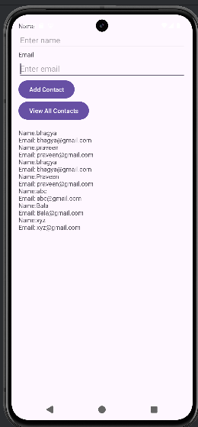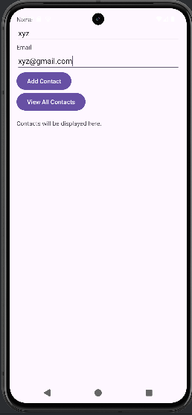

**10. Create an application to send SMS and receive SMS.**

**AndroidManifest.xml**

<?xml version="1.0" encoding="utf-8"?>  
<manifest xmlns:android="http://schemas.android.com/apk/res/android"  
 package="com.example.bca.sms">  
 <uses-feature  
 android:name="android.hardware.telephony"  
 android:required="false" />  
 <uses-permission android:name="android.permission.SEND_SMS"/>  
   
 <application  
 android:allowBackup="true"  
 android:icon="@mipmap/ic_launcher"  
 android:label="@string/app_name"  
 android:roundIcon="@mipmap/ic_launcher_round"  
 android:supportsRtl="true"  
 android:theme="@style/Base.Theme.SMS">  
 <activity  
 android:name="com.example.bca.sms.MainActivity"  
 android:exported="true">  
 <intent-filter>  
 <action android:name="android.intent.action.MAIN" />  
 <category android:name="android.intent.category.LAUNCHER" />  
 </intent-filter>  
 </activity>  
 </application>  
</manifest>

**MainActivity.java**

package com.example.bca.sms;  
  
import android.Manifest;  
import android.content.pm.PackageManager;  
import android.os.Bundle;  
import android.telephony.SmsManager;  
import android.view.View;  
import android.widget.Button;  
import android.widget.EditText;  
import android.widget.Toast;  
import androidx.annotation.NonNull;  
import androidx.appcompat.app.AppCompatActivity;  
import androidx.core.app.ActivityCompat;  
import androidx.core.content.ContextCompat;  
  
public class MainActivity extends AppCompatActivity {  
 private static final int *PERMISSION_REQUEST_CODE* = 1;  
 private EditText phoneNumberEditText;  
 private EditText messageEditText;  
 private Button sendSmsButton;  
 @Override  
 protected void onCreate(Bundle savedInstanceState)  
 {  
 super.onCreate(savedInstanceState);  
 setContentView(R.layout. *activity_main*);  
 phoneNumberEditText = findViewById(R .id.*phone_number*);  
 messageEditText = findViewById(R.id.*message*);  
 sendSmsButton = findViewById(R .id.*send_sms*);  
 sendSmsButton.setOnClickListener(new View.OnClickListener() {  
 @Override  
 public void onClick(View v)  
 {  
 if (ContextCompat.*checkSelfPermission*(MainActivity.this,  
 Manifest.permission.*SEND_SMS*)!= PackageManager.*PERMISSION_GRANTED*)  
 {  
 ActivityCompat.*requestPermissions*(MainActivity.this, new String[]  
 {Manifest.permission.*SEND_SMS*}, *PERMISSION_REQUEST_CODE*);  
 }  
 else  
 {  
 sendSms();  
 }  
 }  
 } ) ;  
 }  
 private void sendSms() {  
 String phoneNumber = phoneNumberEditText.getText().toString();  
 String message = messageEditText.getText().toString();  
 try {  
 SmsManager smsManager = SmsManager.*getDefault*();  
 smsManager.sendTextMessage(phoneNumber, null, message, null, null);  
 Toast.*makeText*(this, "SMS Sent", Toast.*LENGTH_SHORT*).show();  
 phoneNumberEditText.setText("");  
 messageEditText.setText("");  
 }  
 catch (Exception e) {  
 Toast.*makeText*(this, "SMS Failed to Send", Toast.*LENGTH_SHORT*).show();  
 e.printStackTrace();  
 }  
 }  
 @Override  
 public void onRequestPermissionsResult(int requestCode, @NonNull String[]  
 permissions, @NonNull int[] grantResults)  
 {  
 super.onRequestPermissionsResult(requestCode, permissions, grantResults);  
 if (requestCode == *PERMISSION_REQUEST_CODE*)  
 {  
 if (grantResults.length > 0 && grantResults[0]  
 == PackageManager.*PERMISSION_GRANTED*) {  
 sendSms();  
 } else  
 {  
 Toast.*makeText*(this, "Permission Denied", Toast.*LENGTH_SHORT*).show();  
 }  
 }  
 }  
}

**activity_main.xml**

<?xml version="1.0" encoding="utf-8"?>  
<LinearLayout xmlns:android="http://schemas.android.com/apk/res/android"  
 android:layout_width="match_parent"  
 android:layout_height="match_parent"  
 android:orientation="vertical"  
 android:padding="16dp" >  
  
 <EditText  
 android:id="@+id/phone_number"  
 android:layout_width="wrap_content"  
 android:layout_height="wrap_content"  
 android:hint=" Please Enter Phone Number"  
 android:inputType="phone" />  
  
 <EditText  
 android:id="@+id/message"  
 android:layout_width="match_parent"  
 android:layout_height="wrap_content"  
 android:hint="M e s s a g e "  
 android:inputType="textMultiLine" />  
  
 <Button  
 android:id="@+id/send_sms"  
 android:layout_width="match_parent"  
 android:layout_height="wrap_content"  
 android:text="Send SMS" />  
  
</LinearLayout>

**Output**

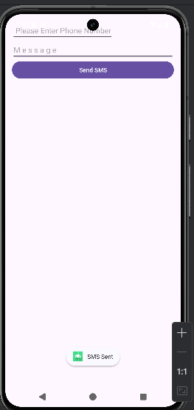

**11.Create an application to send an e-mail**

**activity_main.xml**

<?xml version="1.0" encoding="utf-8"?>  
<RelativeLayout xmlns:android="http://schemas.android.com/apk/res/android"  
 xmlns:tools="http://schemas.android.com/tools"  
 tools:context=".MainActivity"  
 android:layout_width="match_parent"  
 android:layout_height="match_parent"  
 android:paddingLeft="20dp"  
 android:paddingRight="20dp"  
 android:orientation="horizontal">  
  
 <EditText

android:id="@+id/etTo"  
 android:layout_width="wrap_content"  
 android:layout_height="wrap_content"  
 android:layout_alignParentEnd="true"  
 android:layout_alignParentTop="true"  
 android:layout_marginEnd="22dp"  
 android:layout_marginTop="16dp"  
 android:ems="10" />  
  
 <EditText  
 android:id="@+id/etSub"  
 android:layout_width="wrap_content"  
 android:layout_height="wrap_content"  
 android:layout_alignLeft="@+id/etTo"  
 android:layout_below="@+id/etTo"  
 android:layout_marginTop="18dp"  
 android:ems="10" >  
 </EditText>  
  
 <EditText  
 android:id="@+id/etMsg"  
 android:layout_width="wrap_content"  
 android:layout_height="wrap_content"  
 android:layout_alignLeft="@+id/etSub"  
 android:layout_below="@+id/etSub"  
 android:layout_marginTop="28dp"  
 android:ems="10"  
 android:inputType="textMultiLine" />  
  
 <TextView  
 android:id="@+id/textView1"  
 android:layout_width="wrap_content"  
 android:layout_height="wrap_content"  
 android:layout_alignBaseline="@+id/etTo"  
 android:layout_alignBottom="@+id/etTo"  
 android:layout_alignParentLeft="true"  
 android:text="To:" />  
  
 <TextView  
 android:id="@+id/textView2"  
 android:layout_width="wrap_content"  
 android:layout_height="wrap_content"  
 android:layout_alignBaseline="@+id/etSub"  
 android:layout_alignBottom="@+id/etSub"  
 android:layout_alignParentLeft="true"  
 android:text="Subject:" />  
  
 <TextView  
 android:id="@+id/textView3"  
 android:layout_width="wrap_content"  
 android:layout_height="wrap_content"  
 android:layout_alignBaseline="@+id/etMsg"  
 android:layout_alignBottom="@+id/etMsg"  
 android:layout_alignParentLeft="true"  
 android:text="Message:" />  
  
 <Button  
 android:id="@+id/btSend"  
 android:layout_width="wrap_content"  
 android:layout_height="wrap_content"  
 android:layout_alignLeft="@+id/etMsg"  
 android:layout_below="@+id/etMsg"  
 android:layout_marginLeft="76dp"  
 android:layout_marginTop="20dp"  
 android:text="Send" />  
  
</RelativeLayout>

**MainActivity.java**

package com.example.bca.email;  
  
import android.content.Intent;  
import androidx.appcompat.app.AppCompatActivity;  
import android.os.Bundle;  
import android.view.View;  
import android.widget.Button;  
import android.widget.EditText;  
  
public class MainActivity extends AppCompatActivity  
{  
 EditText etTo, etSub, etMsg;  
 Button btSend;  
 String to, subject, message;  
  
 @Override  
 protected void onCreate(Bundle savedInstanceState)  
 {  
 super.onCreate(savedInstanceState);  
 setContentView(R.layout.*activity_main*);  
 etTo = (EditText) findViewById(R.id.*etTo*);  
 etSub = (EditText) findViewById(R.id.*etSub*);  
 etMsg = (EditText) findViewById(R.id.*etMsg*);  
  
 btSend = (Button) findViewById(R.id.*btSend*);  
 btSend.setOnClickListener(new View.OnClickListener()  
 {  
 @Override  
 public void onClick(View view) {  
 to = etTo.getText().toString();  
 subject = etSub.getText().toString();  
 message = etMsg.getText().toString();  
  
 Intent email = new Intent(Intent.*ACTION_SEND*);  
 email.putExtra(Intent.*EXTRA_EMAIL*, new String[]{to});  
 email.putExtra(Intent.*EXTRA_SUBJECT*, subject);  
 email.putExtra(Intent.*EXTRA_TEXT*, message);  
  
 //need this to prompts email client only  
  
 email.setType("message/rfc822");  
 startActivity(Intent.*createChooser*(email, "Choose Email client :"));  
 }  
 });  
 }  
}

**Output**

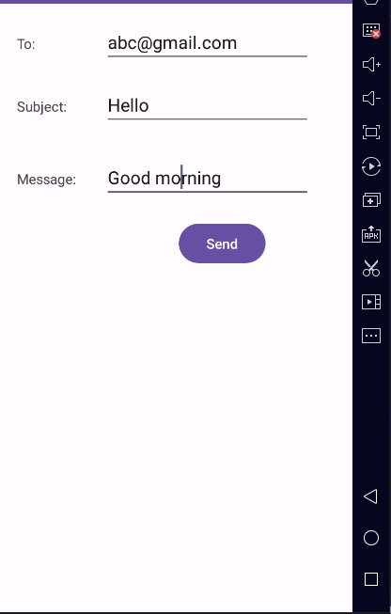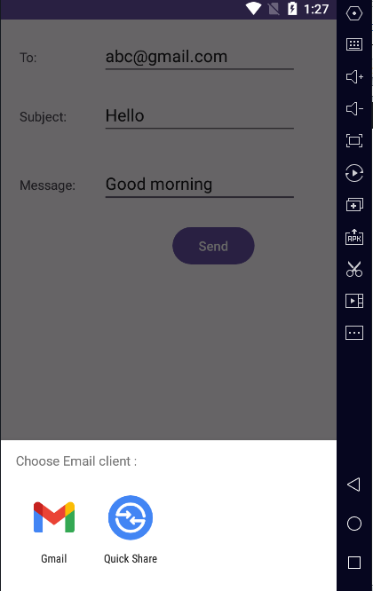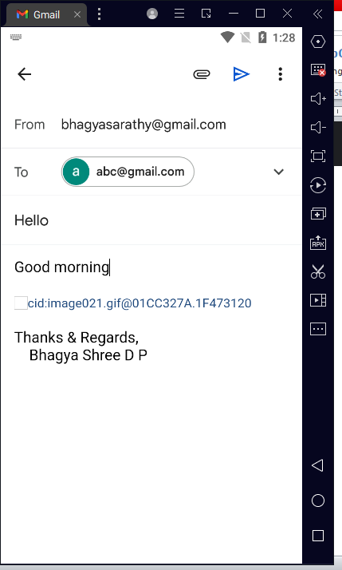

**12. Display Map based on the Current/given location.**

**Update Manifest file**

<?xml version="1.0" encoding="utf-8"?>  
<manifest xmlns:android="http://schemas.android.com/apk/res/android"  
 xmlns:tools="http://schemas.android.com/tools"  
 package="com.example.bca.locationmaps">  
  
 <uses-permission android:name="android.permission.ACCESS_FINE_LOCATION" />  
 <uses-permission android:name="android.permission.ACCESS_COARSE_LOCATION" />  
 <uses-permission android:name="android.permission.INTERNET" />  
  
 <application  
 android:allowBackup="true"  
 android:icon="@mipmap/ic_launcher"  
 android:label="@string/app_name"  
 android:roundIcon="@mipmap/ic_launcher_round"  
 android:supportsRtl="true"  
 android:theme="@style/Theme.LocationMaps"  
 tools:targetApi="31">  
 <meta-data  
 android:name="com.google.android.geo.API_KEY"  
 android:value="YOUR_API_KEY_HERE" />  
 <activity  
 android:name=".MainActivity"  
 android:exported="true">  
 <intent-filter>  
 <action android:name="android.intent.action.MAIN" />  
 <category android:name="android.intent.category.LAUNCHER" />  
 </intent-filter>  
 </activity>  
 </application>  
  
</manifest>

**MainActivity.java**

package com.example.bca.locationmaps;  
  
import android.os.Bundle;  
import android.widget.Toast;  
import androidx.annotation.NonNull;  
import androidx.appcompat.app.AppCompatActivity;  
import com.google.android.gms.maps.CameraUpdateFactory;  
import com.google.android.gms.maps.GoogleMap;  
import com.google.android.gms.maps.MapView;  
import com.google.android.gms.maps.MapsInitializer;  
import com.google.android.gms.maps.OnMapReadyCallback;  
import com.google.android.gms.maps.SupportMapFragment;  
import com.google.android.gms.maps.model.LatLng;  
import com.google.android.gms.maps.model.MarkerOptions;  
  
public class MainActivity extends AppCompatActivity  
{  
 private MapView mapView;  
 private GoogleMap googleMap;  
  
 @Override  
 protected void onCreate(Bundle savedInstanceState)  
 {  
 super.onCreate(savedInstanceState);  
 setContentView(R.layout.*activity_main*);  
  
 mapView = findViewById(R.id.*mapView*);  
 mapView.onCreate(savedInstanceState);  
 mapView.onResume();  
  
 try  
 {  
 MapsInitializer.*initialize*(this);  
 }  
 catch (Exception e)  
 {  
 e.printStackTrace();  
 }  
  
 mapView.getMapAsync(new OnMapReadyCallback()  
 {  
 @Override  
 public void onMapReady(GoogleMap mMap)  
 {  
 googleMap = mMap;  
 googleMap.setMapType(GoogleMap.*MAP_TYPE_NORMAL*);  
 googleMap.getUiSettings().setZoomControlsEnabled(true);  
 }  
 }) ;  
 }  
 @Override  
 protected void onResume()  
 {  
 super.onResume();  
 mapView.onResume();  
 }  
 @Override  
 protected void onPause()  
 {  
 super.onPause();  
 mapView.onPause();  
 }  
 @Override  
 protected void onDestroy()  
 {  
 super.onDestroy();  
 mapView.onDestroy();  
 }  
 @Override  
 public void onLowMemory()  
 {  
 super.onLowMemory();  
 mapView.onLowMemory() ;  
 }  
}

**activity_main.xml**

<?xml version="1.0" encoding="utf-8"?>  
 <androidx.constraintlayout.widget.ConstraintLayout  
 xmlns:android="http://schemas.android.com/apk/res/android"  
 xmlns:app="http://schemas.android.com/apk/res-auto"  
 xmlns:tools="http://schemas.android.com/tools"  
 android:id="@+id/main"  
 android:layout_width="match_parent"  
 android:layout_height="match_parent"  
 tools:context=".MainActivity">  
  
 <com.google.android.gms.maps.MapView  
 android:id="@+id/mapView"  
 android:layout_width="match_parent"  
 android:layout_height="match_parent"/>  
  
</androidx.constraintlayout.widget.ConstraintLayout>

**Output**

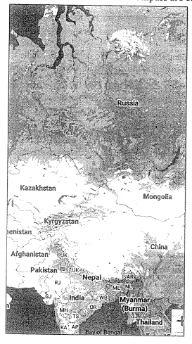

**13. Create a sample application with login module (check user name and password) On successful login change Textview “Login Successful”. On login fail alert using Toast “login fail”**

**Activity_main.xml**

<?xml version="1.0" encoding="utf-8"?>  
<RelativeLayout  
 xmlns:android="http://schemas.android.com/apk/res/android"  
 android:layout_width="match_parent"  
 android:layout_height="match_parent" >  
  
 <TextView  
 android:id="@+id/tvName"  
 android:layout_width="wrap_content"  
 android:layout_height="wrap_content"  
 android:layout_marginStart="21dp"  
 android:layout_marginTop="49dp"  
 android:text="User Name"  
 android:textSize="18sp" />  
  
 <EditText  
 android:id="@+id/etUsername"  
 android:layout_width="wrap_content"  
 android:layout_height="wrap_content"  
 android:layout_alignBaseline="@+id/tvName"  
 android:layout_alignBottom="@+id/tvName"  
 android:layout_alignParentEnd="true"  
 android:layout_marginEnd="23dp"  
 android:ems="10"  
 android:inputType="textPersonName" />  
  
 <TextView android:id="@+id/tvPass"  
 android:layout_width="wrap_content"  
 android:layout_height="wrap_content"  
 android:layout_alignEnd="@+id/tvName"  
 android:layout_below="@+id/etUsername"  
 android:layout_marginTop="32dp"  
 android:text="Password"  
 android:textSize="18sp" />  
  
 <EditText  
 android:id="@+id/etPassword"  
 android:layout_width="wrap_content"  
 android:layout_height="wrap_content"  
 android:layout_alignBaseline="@+id/tvPass"  
 android:layout_alignBottom="@+id/tvPass"  
 android:layout_alignStart="@+id/etUsername"  
 android:ems="10"  
 android:inputType="textPassword" />  
  
 <Button  
 android:id="@+id/button"  
 android:layout_width="wrap_content"  
 android:layout_height="wrap_content"  
 android:layout_below="@+id/etPassword"  
 android:layout_centerHorizontal="true"  
 android:layout_marginTop="38dp"  
 android:text="LOGIN"/>  
  
 <TextView android:id="@+id/LoginStatus"  
 android:layout_width="wrap_content"  
 android:layout_height="wrap_content"  
 android:layout_below="@id/button"  
 android:layout_centerHorizontal="true"  
 android:layout_marginTop="100sp" />  
  
</RelativeLayout>

**MainActivity.java**

package com.example.bca.loginmodule;  
  
import androidx.appcompat.app.AppCompatActivity;  
import android.os.Bundle;  
import android.view.View;  
import android.widget.Button;  
import android.widget.EditText;  
import android.widget.TextView;  
import android.widget.Toast;  
  
public class MainActivity extends AppCompatActivity  
{  
 EditText etUsername, etPassword; Button btnStatus; TextView LoginStatus;  
 @Override  
 protected void onCreate(Bundle savedInstanceState)  
 {  
 super.onCreate(savedInstanceState);  
 setContentView(R.layout.*activity_main*);  
 etUsername = (EditText) findViewById(R.id.*etUsername*);  
 etPassword = (EditText) findViewById(R.id.*etPassword*);  
 btnStatus = (Button) findViewById(R.id.*button*);  
 LoginStatus = (TextView) findViewById(R.id.*LoginStatus*);  
 btnStatus.setOnClickListener(new View.OnClickListener()  
 {  
 @Override  
 public void onClick(View v)  
 {  
 check();  
 }  
 });  
 }  
 public void check()  
 {  
 if(etUsername.getText().toString().equals("admin")  
 && etPassword.getText().toString().equals("password"))  
 {  
 LoginStatus.setText("Login successful");  
 etUsername.setText("");  
 etPassword.setText("");  
 }  
 else  
 {  
 LoginStatus.setText("Login fail");  
 }  
 }  
}

**df’[**

**Output**

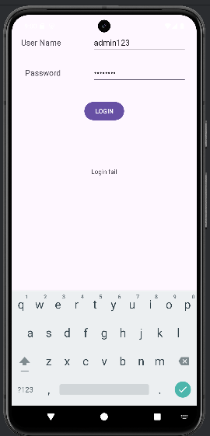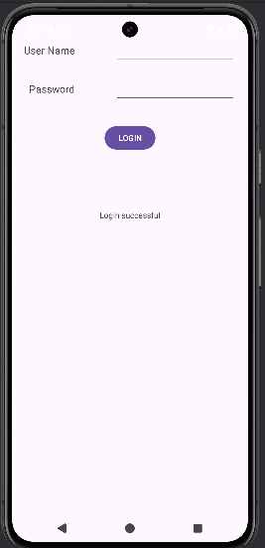

**Program 14**

Learn to deploy Android applications

**Steps to Deploy an Android Application**

1. **Prepare App** (use Program 1 Hello world for this program)

* Optimize performance and test thoroughly.
* Ensure compatibility with various devices

**activity_main.xml**

<?xml version="1.0" encoding="utf8"?>

<androidx.constraintlayout.widget.ConstraintLayout

xmlns:android="http://schemas.android.com/apk/res/android"

xmlns:app="http://schemas.android.com/apk/resauto"

xmlns:tools="http://schemas.android.com/tools"

android:layout_width="match_parent"

android:layout_height="match_parent"

tools:context=".MainActivity">

<TextView

android:layout_width="wrap_content"

android:layout_height="wrap_content"

android:text="Hello World!"

app:layout_constraintBottom_toBottomOf="parent"

app:layout_constraintEnd_toEndOf="parent"

app:layout_constraintStart_toStartOf="parent"

app:layout_constraintTop_toTopOf="parent"

android:textSize="30sp"/>

</androidx.constraintlayout.widget.ConstraintLayout>

**MainActivity.java**

package com.bca.helloworld;

import androidx.appcompat.app.AppCompatActivity;

import android.os.Bundle;

public class MainActivity extends AppCompatActivity

{

protected void onCreate(Bundle savedInstanceState)

{

super.onCreate(savedInstanceState);

setContentView(R.layout.*activity_main*);

}

}

1. **Generate Signed APK (Android Package Kit**):

• In Android Studio, navigate to Build > Generate Signed Bundle/APK.

• Follow the prompts to create a new keystore or use an existing one. A keystore is a

binary file that contains a set of private keys.

• Configure the build type (release) and signing configuration.

• Generate the signed APK file.

3. **Test Your Signed APK**:

• Before distributing your app, test the signed APK to ensure that the signing process

didn't introduce any issues.

• Install the APK on various devices and perform thorough testing.

• Release on Google Play Console:

• Sign in to the Google Play Console (https://play.google.com/apps/publish).

• Create a new app entry if this is your first release or select an existing app.

• Complete all the required information for the app listing, including the title, description,

screenshots, and categorization.

• Upload your signed APK file.

• Set pricing and distribution options.

• Optimize your store listing for search and conversion.

• Once everything is set, click the "Publish" button to release your app to the Google Play

Store.

4. **Other Distribution Channels (Optional):**

• Besides Google Play, you can distribute your app through other channels such as

Amazon Appstore, Samsung Galaxy Store, or thirdparty app marketplaces.

Each distribution channel may have its own requirements and submission process, so

be sure to follow their guidelines.

5. **Monitor and Update**:

• Keep an eye on user feedback and app performance metrics through the Google Play

Console.

• Regularly update your app to fix bugs, add new features, and improve user experience

based on feedback.